FIT FOR LIFE – ICLANDIC STUDENT´S POSTERS OF THE TOPICS
Trying to keep the project alive in the minds of our students we decided to divide them into smaller groups where we discussed the different topics of the project. The students talked among themselves what these concepts meant to them and what it incorporated in their minds. The outcome was a poster from each group that represented their ideas of what the given topic meant to them. The results can be seen below.
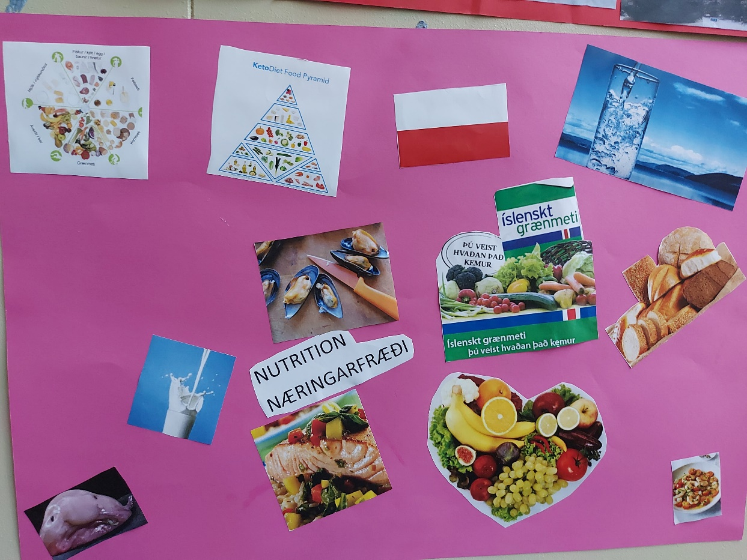
NUTRITION:

CULTURE:
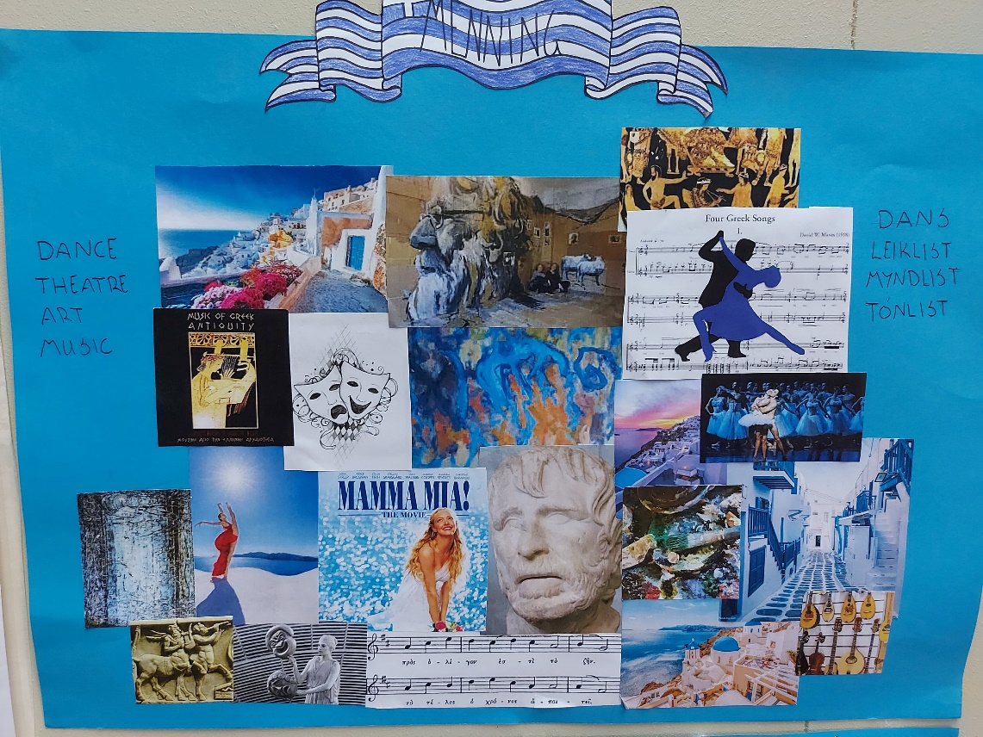

RESPONSIBLE CITIZEN:
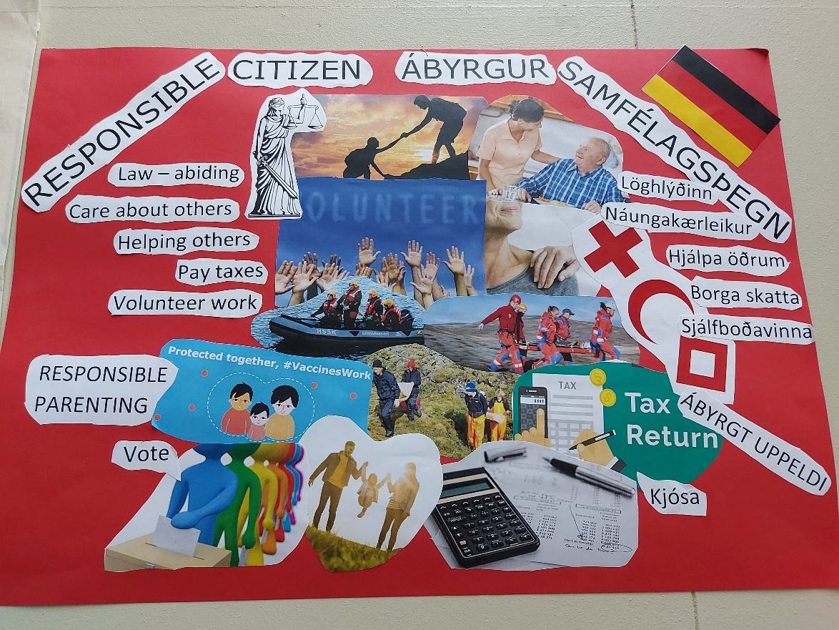

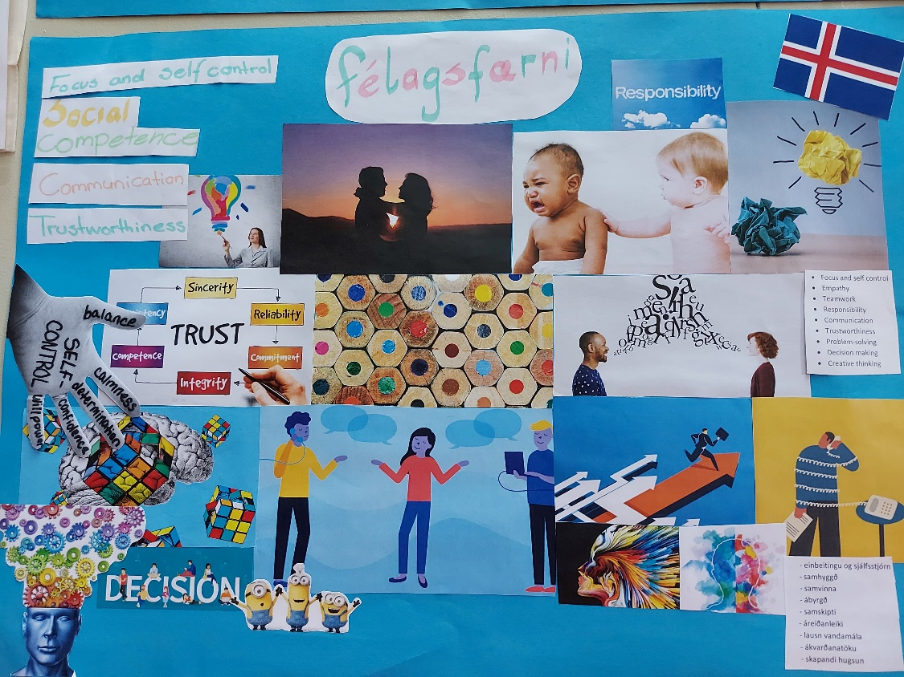
SOCIAL SKILLS:

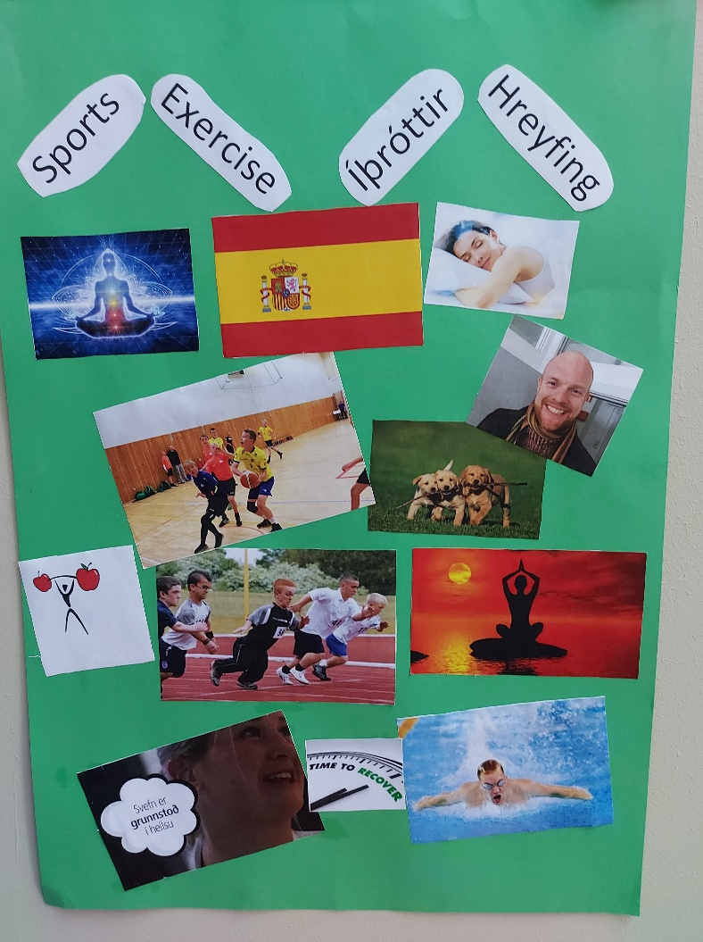
SPORTS:

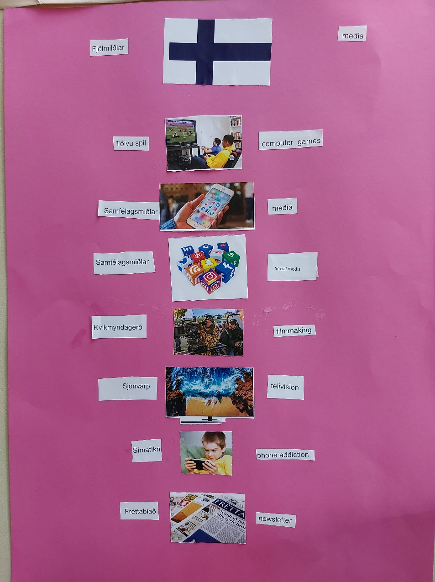
MEDIA:

