THE ERASMUS+ WALL IN VÍKURSKÓLI ICELAND
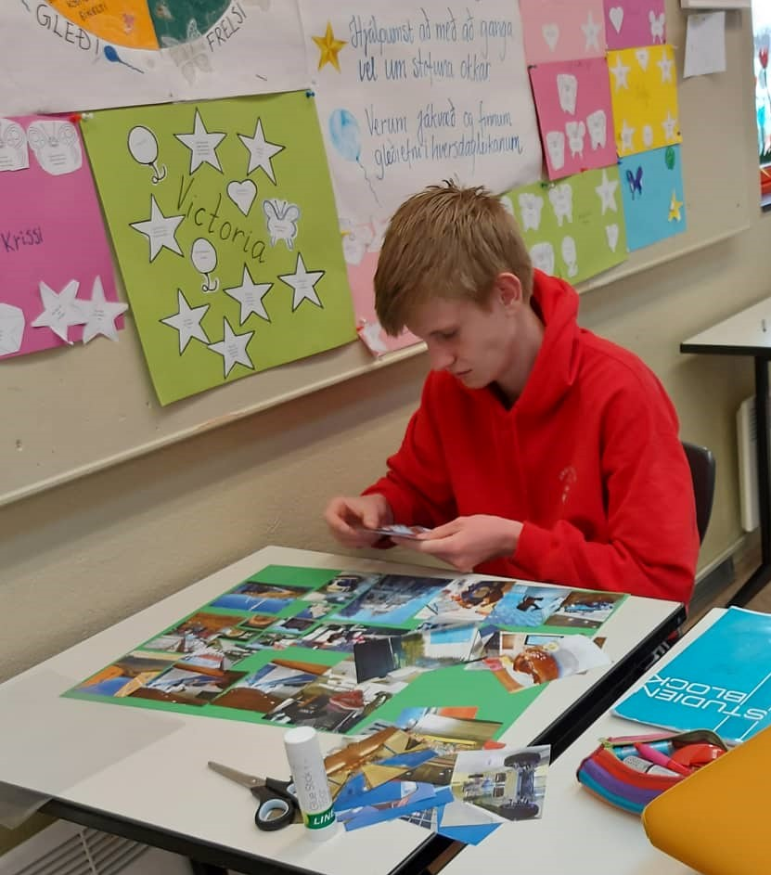

Working on poster for the Erasmus+ wall.
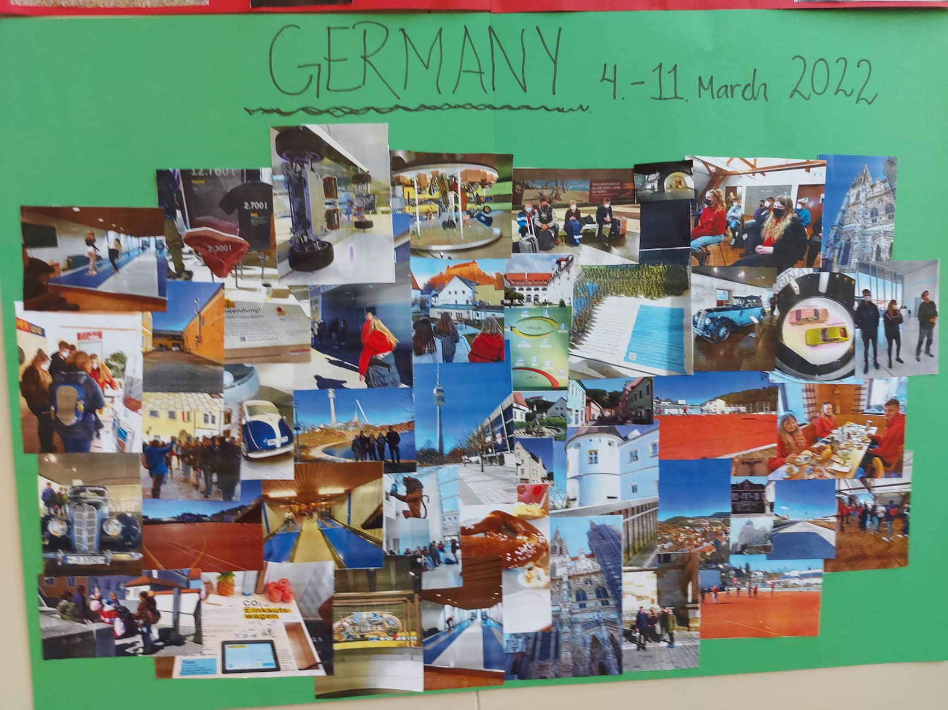

The outcome
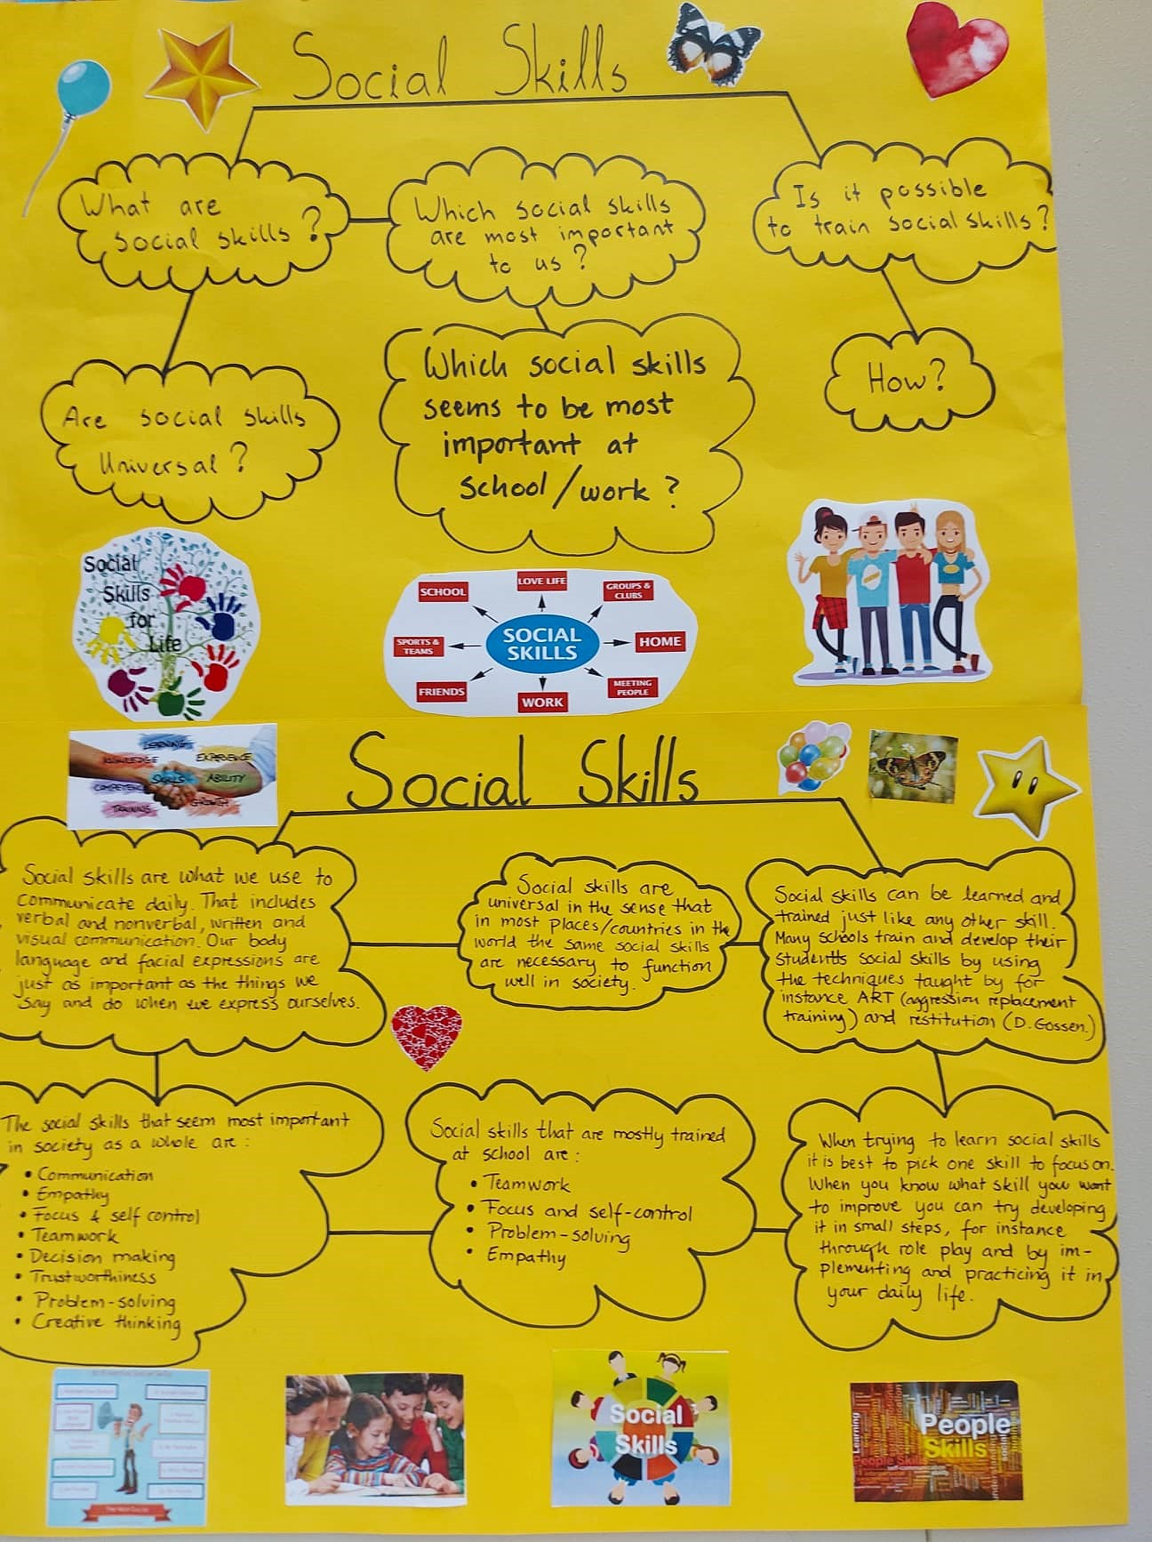

Posters on social skills – questions and answers

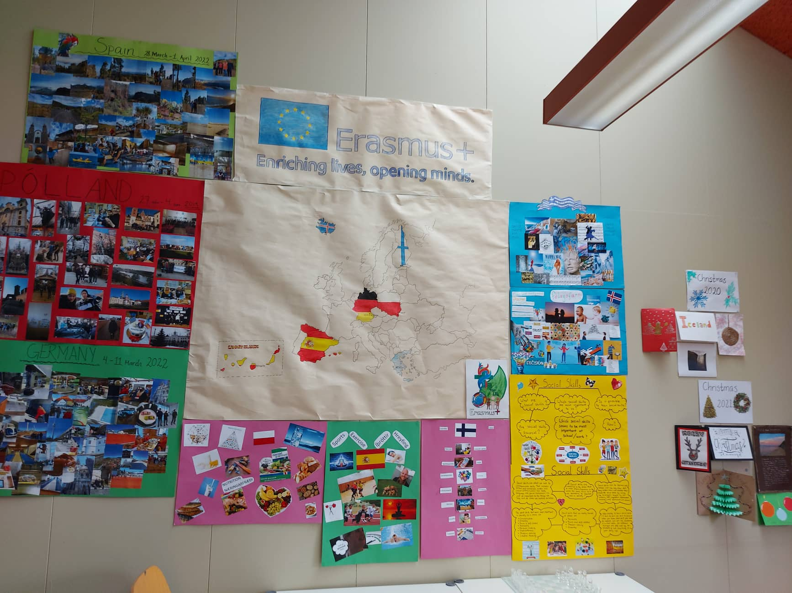

Our Erasmus+ wall
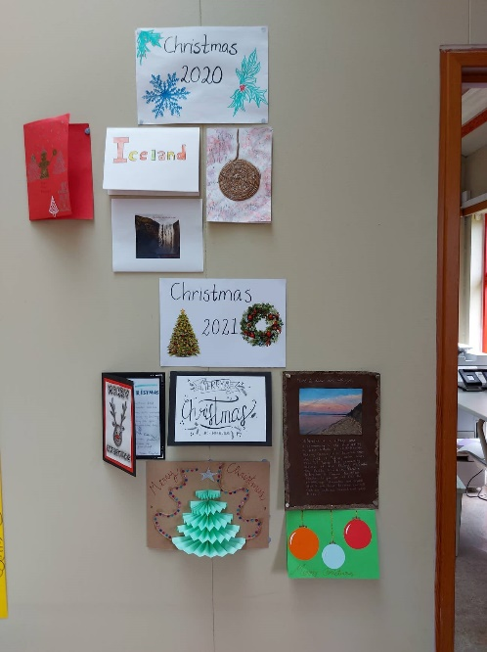
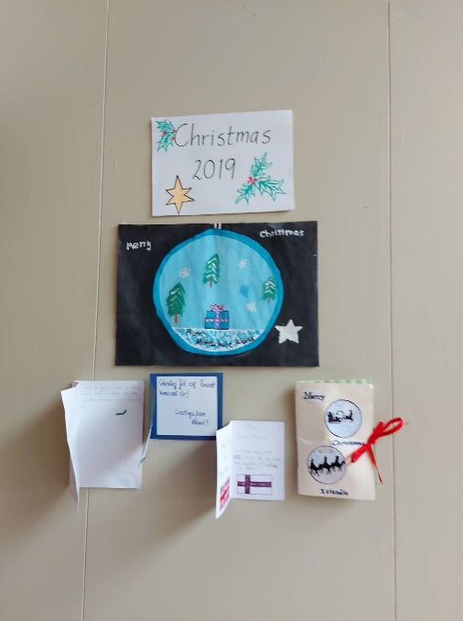

Christmas cards 2019 Christmas cards 2020 - 2021

